

**National University of Technology**

|  |
| --- |
| **Group Members** |

Semester fall – 2025

**Program:** Artificial intelligence

**Course:** Programming for AI

**Course Code:** CS282

|  |
| --- |
| **Instructor**  Lec. Umar Aftab  umaraftab@nutech.edu.pk |
|  |

imaanaftabf23@nutech.edu.pk

Imaan Aftab

F23607041

*emankainif23@nutech.edu.pk*

Eman Asghar Kiani

F23607010

**CV Screening Agent**

PFAI – Theory Project

Table of Contents

1. Research Report 3

1.1 Introduction 3

1.2 AI Agent Modeling Concepts 3

i. What is an AI Agent? 3

ii. Types of AI Agents 3

iii. Role of AI Agents in Automation 3

1.3 Tool Exploration: n8n and other tools 3

i. Overview of n8n 3

ii. Key Features for AI Agent Development 4

1.4 Implementation: Automated CV Screening Agent 4

i. Workflow Structure & Components 4

ii. Node-by-Node Breakdown 5

1.5 WORKFLOWS 7

1.6 Evaluation and Performance Analysis 7

i. Strengths 7

ii. Limitations & Challenges 7

1.7 Future Improvements and Scalability 8

2. Technical Documentation 9

2.1. Overview 9

2.2. Workflow Design 9

i. Architecture 9

ii. Key Technologies 9

2.3. Implementation Details 10

i. Node Connections and Data flow 10

*ii.* Detailed Node specifications 10

2.4. Example Workflow Execution 17

2.5. Testing and Validation 17

1.2.1 17

2.6. Future Improvements 18

2.7. Conclusion 18

References 19

**LIST OF FIGURES**

Figure 1 n8n overview 4

Figure 2 Application Form node 5

Figure 3 Convert binary to JSON1 node 5

Figure 4 LangChain node 6

Figure 5 Candidate list sheet node 6

Figure 6 HR mail node 6

Figure 7 Applicant mail node 7

Figure 8 Final workflow 7

Figure 9 Application form 10

Figure 10 Form Submitted 11

Figure 11 Application form detail 11

Figure 12 Convert binary to JSON1 detail 11

Figure 13 Binary to JSON node output 12

Figure 14 GROK node detail 12

Figure 15 AI Analysis node output + Figure 16 AI Analysis node detail 13

Figure 17 Candidate list detail1 14

Figure 18 Candiate list detail 2 14

Figure 19 Final sheet 15

Figure 20 HR email node detail 15

Figure 21 HR email sent 16

Figure 22 Applicant email node detail 16

Figure 23 Applicant email sent 17

Figure 24 Workflow execution 17

# Research Report

## Introduction

The rapid advancement of artificial intelligence (AI) and automation tools has revolutionized recruitment processes. AI-powered agents can now assist in screening resumes, analyzing candidate suitability, and automating communication. This report explores the design and implementation of an **Automated CV Screening Agent** built using **n8n**, a low-code workflow automation tool.

The agent performs the following tasks:

* Receives candidate applications via a web form.
* Extracts and analyzes CV data using AI (LangChain & Groq).
* Stores candidate details in Google Sheets.
* Sends confirmation emails to candidates and notifications to HR.

**This report examines AI agent modeling concepts, the n8n tool, and the practical implementation of the workflow.**

## AI Agent Modeling Concepts

### ****What is an AI Agent?****

An AI agent is an autonomous system that perceives its environment through sensors and acts upon it using actuators. In this context:

**Sensors**: Input data (CVs, form submissions).

**Actuators**: Automated emails, database updates, AI analysis.

### Types of AI Agents

**Simple Reflex Agents**: React to immediate inputs (e.g., sending an email confirmation).

**Model-Based Agents**: Maintain internal state (e.g., tracking candidate data in Google Sheets).

**Goal-Based Agents**: Work towards objectives (e.g., AI analysis for hiring recommendations).

**Utility-Based Agents**: Optimize decisions (e.g., ranking candidates based on AI scoring).

### Role of AI Agents in Automation

AI agents enhance efficiency by:

* Reducing manual screening time.
* Providing consistent, unbiased candidate evaluations.
* Automating repetitive HR tasks.

## Tool Exploration: n8n and other tools

### Overview of n8n

n8n is an **open-source workflow automation tool** that allows users to connect different applications and services using a visual interface.

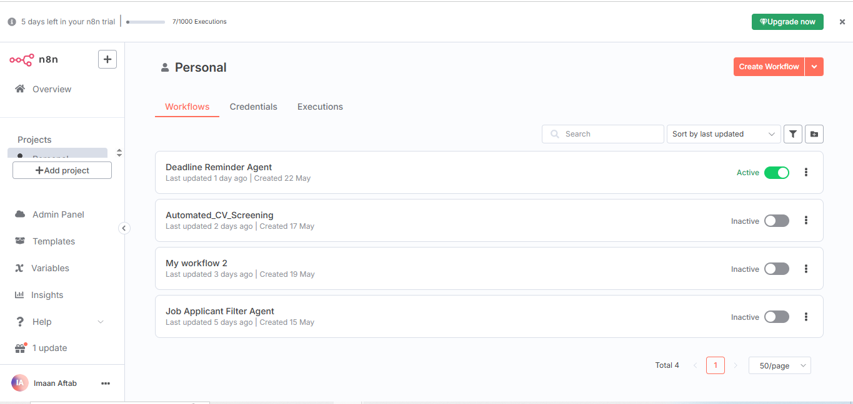

Figure 1 n8n overview

**Key Features:**

**Node-based workflow design** (drag-and-drop).

**Integration with 300+ apps** (Google Sheets, Gmail, OpenAI, etc.).

**Self-hostable & extensible**.

### Key Features for AI Agent Development

**LangChain Node**: Enables AI-powered text analysis.

**Google Sheets Integration**: Stores structured candidate data.

**Gmail Node**: Automates email communication.

**Webhook Triggers**: Captures form submissions.

## Implementation: Automated CV Screening Agent

### ****Workflow Structure & Components****

The workflow consists of **7 nodes**:

* **Application Form (Trigger)** → Captures candidate details.
* **Convert Binary to JSON** → Extracts text from uploaded PDF CVs.
* **AI Analysis & Rating (LangChain + Groq)** → Evaluates CV compatibility.
* **Google Sheets (Candidate List)** → Stores applicant data.
* **Inform HR (Gmail)** → Notifies HR via email.
* **Confirmation Email (Gmail)** → Sends acknowledgment to the candidate.
* **Groq Chat Model** → Powers AI analysis.

### ****Node-by-Node Breakdown****

**1. Application Form (Webhook Trigger)**

Fields: Full Name, Email, LinkedIn, Salary Expectation, Resume (PDF).

Output: Structured JSON data for processing.

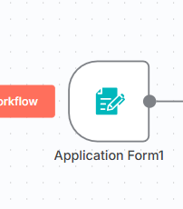

Figure 2 Application Form node

**2. Convert Binary to JSON**

Extracts text from the uploaded PDF resume.

Passes data to the AI analysis node.

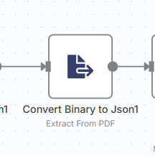

Figure 3 Convert binary to JSON1 node

**3. AI Analysis & Rating (LangChain + Groq)**

**LangChain Node**: Processes natural language prompts.

**Groq AI Model**: Provides fast, low-latency AI responses.

**Prompt Engineering**:

**"Analyze the compatibility of the candidate's resume with the job description (Software Engineer).**

Provide a rating (1-10) and a recommendation."

**Output**: Structured AI-generated feedback.

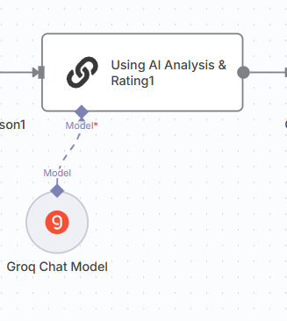

Figure 4 LangChain node

**4. Google Sheets (Candidate List)**

It will store:

Applicant Name, Email, LinkedIn, Salary Expectation.

AI-generated comments and rating.

Timestamp of submission.

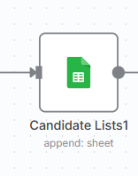

Figure 5 Candidate list sheet node

**5. Inform HR (Gmail)**

Sends an email to HR with candidate details and AI analysis.

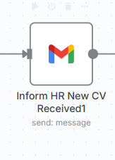

Figure 6 HR mail node

**6. Confirmation Email (Gmail)**

Sends an acknowledgment email to the candidate.

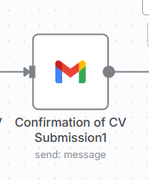

Figure 7 Applicant mail node

## WORKFLOWS

**Final Workflow:**

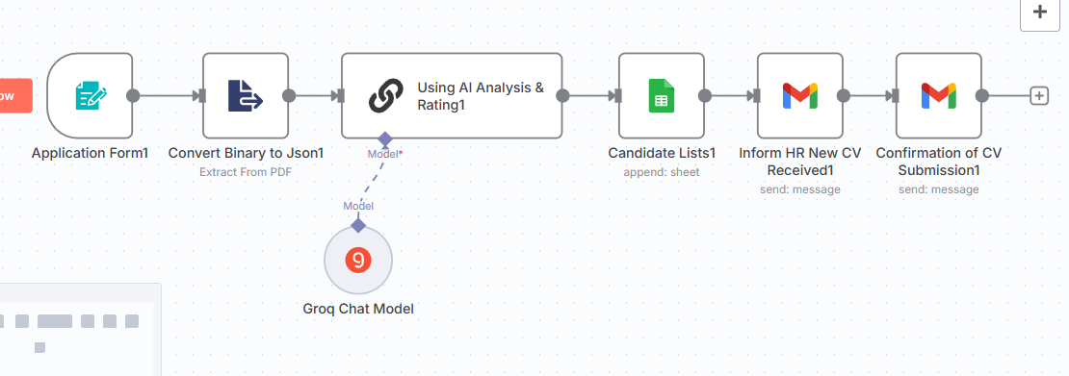

Figure 8 Final workflow

## Evaluation and Performance Analysis

### ****Strengths****

**Fully Automated Process** – Reduces manual HR workload.  
**AI-Powered Decision Support** – Enhances screening accuracy.  
**Scalable** – Can handle multiple applications simultaneously.

### ****Limitations & Challenges****

**Dependence on AI Accuracy** – Biases in AI models may affect fairness.  
**PDF Parsing Errors** – Complex CV formats may not extract correctly.  
**Requires API Setup** – Gmail, Google Sheets, and Groq need authentication.

## Future Improvements and Scalability

**Multi-Language Support** – Expand AI analysis for non-English resumes.

**Advanced AI Fine-Tuning** – Customize prompts for different job roles.

**Integration with ATS** – Link with Applicant Tracking Systems (e.g., Greenhouse).

# 2. Technical Documentation

## 2.1. Overview

The **Automated CV Screening** workflow in n8n is designed to:

* Accept candidate submissions via a web form.
* Extract and analyze CV content using AI.
* Store structured candidate data in Google Sheets.
* Notify HR and send confirmation emails automatically.

# 2.2. Workflow Design

### Architecture

The workflow architecture consists of **7 interconnected nodes**:

|  |  |  |
| --- | --- | --- |
| ****Node**** | ****Function**** | ****Key Parameters**** |
| **Application Form (Trigger)** | Captures candidate details via web form | Fields: Name, Email, LinkedIn, CV (PDF) |
| **Convert Binary to JSON** | Extracts text from uploaded PDF CV | Binary property: Your_Resume_CV |
| **AI Analysis & Rating** | Evaluates CV using LangChain + Groq | Custom prompt for AI scoring (1-10) |
| **Google Sheets** | Stores candidate data | Columns: Name, Email, AI Rating, Timestamp |
| **Inform HR (Gmail)** | Sends HR notification | Dynamic email templating |
| **Confirmation Email (Gmail)** | Sends acknowledgment to candidate | Personalization via {{Full Name}} |
| **Groq Chat Model** | Powers AI analysis | API credentials integration |

### ****Key Technologies****

Following key technologies are used for building this agent:

* **n8n** (Workflow automation)
* **LangChain** (AI text processing)
* **Groq** (High-speed LLM inference)
* **Google Sheets** (Database)
* **Gmail** (Email automation)

# 2.3. Implementation Details

### ****Node Connections and Data flow****

The nodes are connecting in the sequence as given below so as data is also flowing in this sequence.

*Application Form → PDF Extraction → AI Analysis → Google Sheets → HR Email → Candidate Email*

### Detailed Node specifications

#### **A. Application Form (Webhook Trigger)**

**Type**: formTrigger

**Fields**:

* Full Name (Text, Required)
* Email (Validation: Email format)
* LinkedIn (URL)
* Expectation (Text, e.g., "2000-3000$")
* Resume/CV (File upload, PDF only)

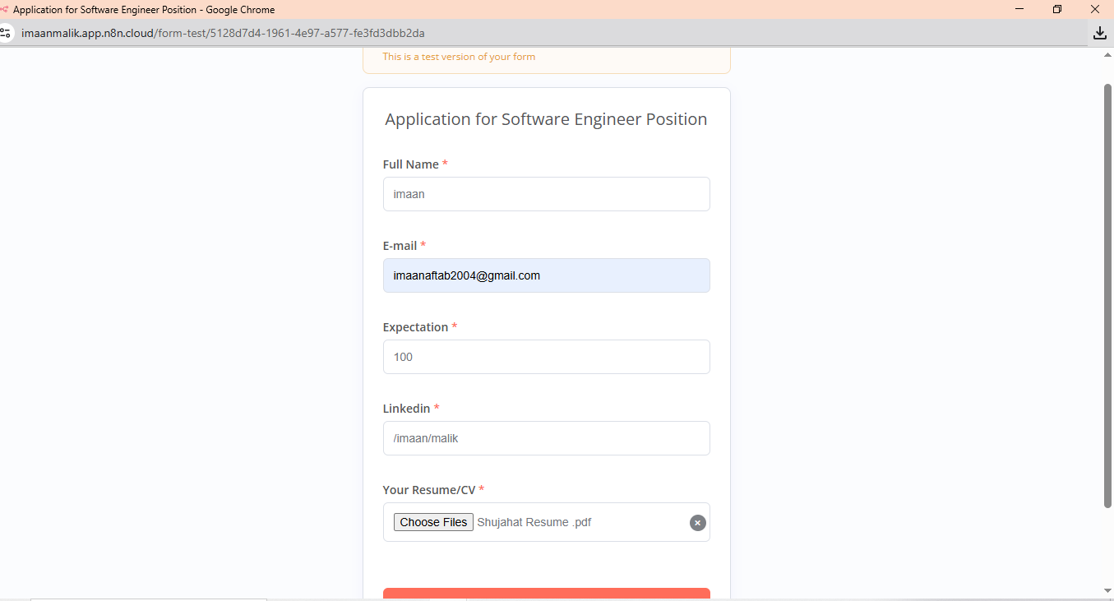

Figure 9 Application form

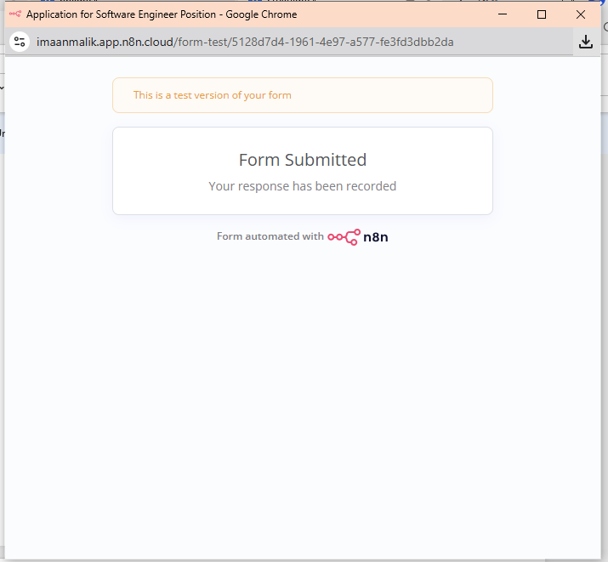

Figure 10 Form Submitted

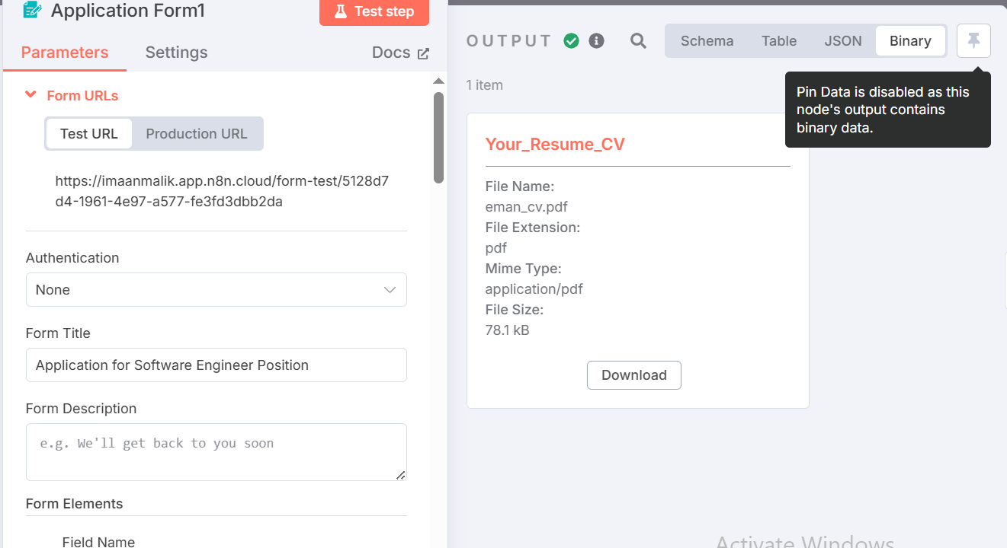

Figure 11 Application form detail

#### **B. Convert Binary to JSON**

**Type**: extractFromFile

**Operation**: PDF text extraction

**Output Property**: text (passed to AI node)

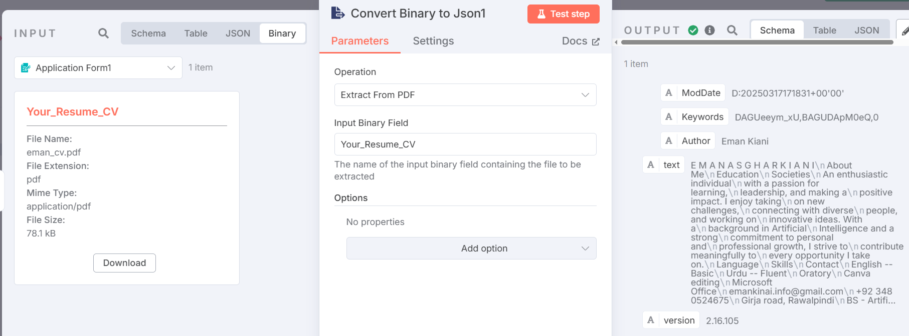

Figure 12 Convert binary to JSON1 detail

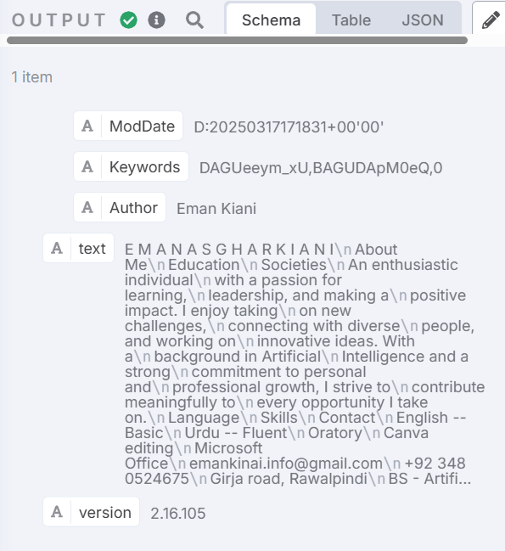

Figure 13 Binary to JSON node output

#### **AI Analysis & Rating (LangChain)**

**Type**: chainLLm

**Model**: Groq (via LLmChatGroq node)

**Prompt**: {{ $json.text }}(from previous node _extracted CV)

**Groq Node Setup**:

**API Credentials**: OAuth2 authentication.

**Model**: llama3-8b-8192

**LangChain Prompt Rules**:

* Strict 75-word limit.
* Avoids markdown formatting.

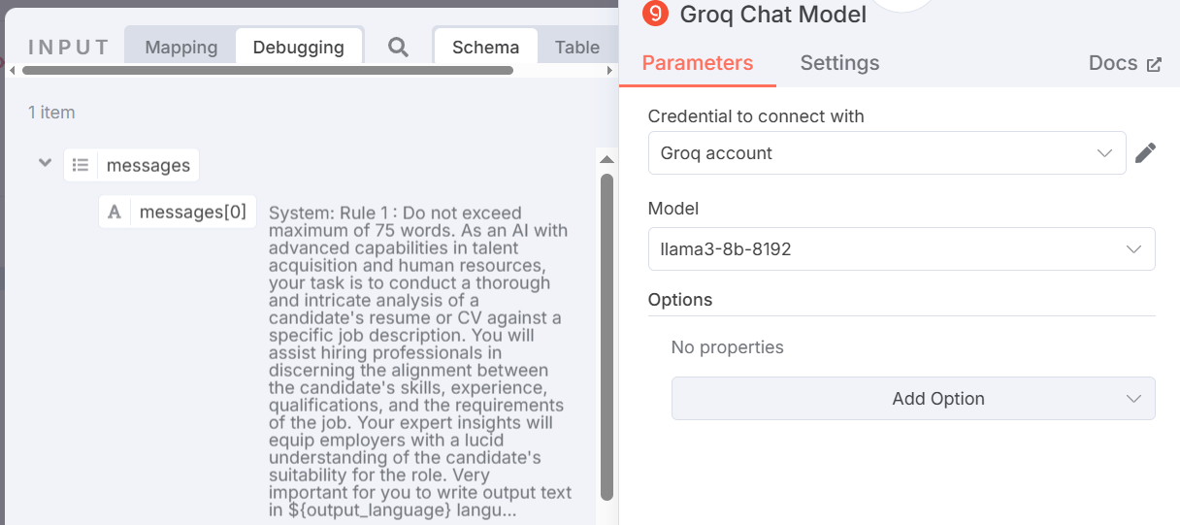

Figure 14 GROK node detail

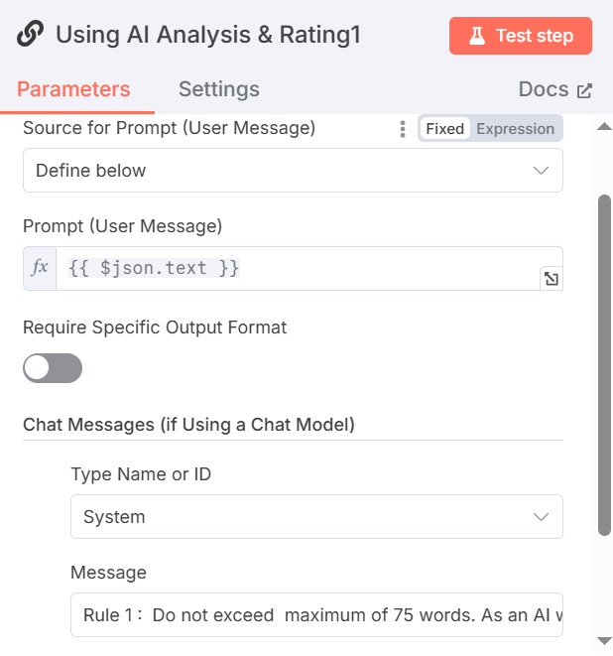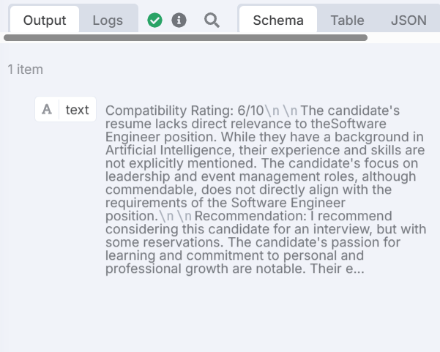

Figure 15 AI Analysis node output Figure 16 AI Analysis node detail

#### **D. Google Sheets**

**Purpose:** Data storage

**Input:** CV analysis text generated from model

**Columns Mapped**: Manually mapping each one

**Output**: Structured information in columns about applicant in Google sheet

**Schema:**

|  |  |  |
| --- | --- | --- |
| **Column** | **Data Type** | **Source** |
| CV | Pdf file | From input |
| Applicant name | String | Form input |
| E-mail | String | Form input |
| Expectation | Number | From input |
| LinkedIn | String | From input |
| Comments | String | LangChain output |
| Date | Timestamp | {{$now}} |

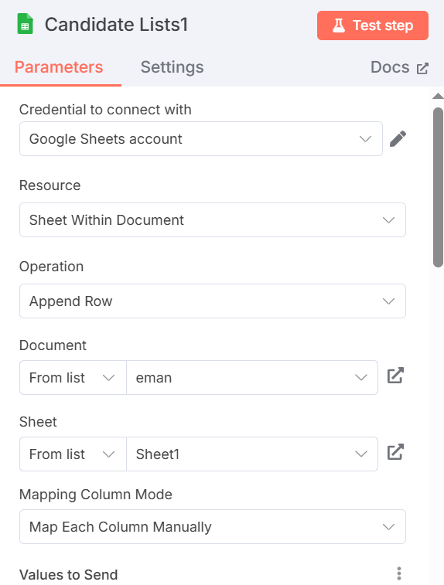

Figure 17 Candidate list detail1

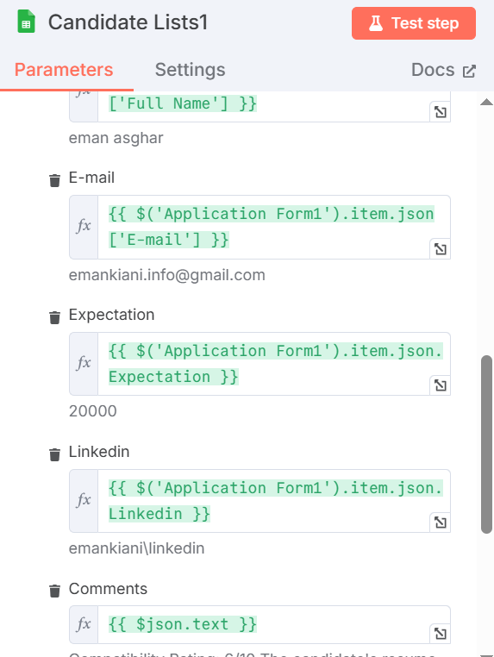

Figure 18 Candiate list detail 2

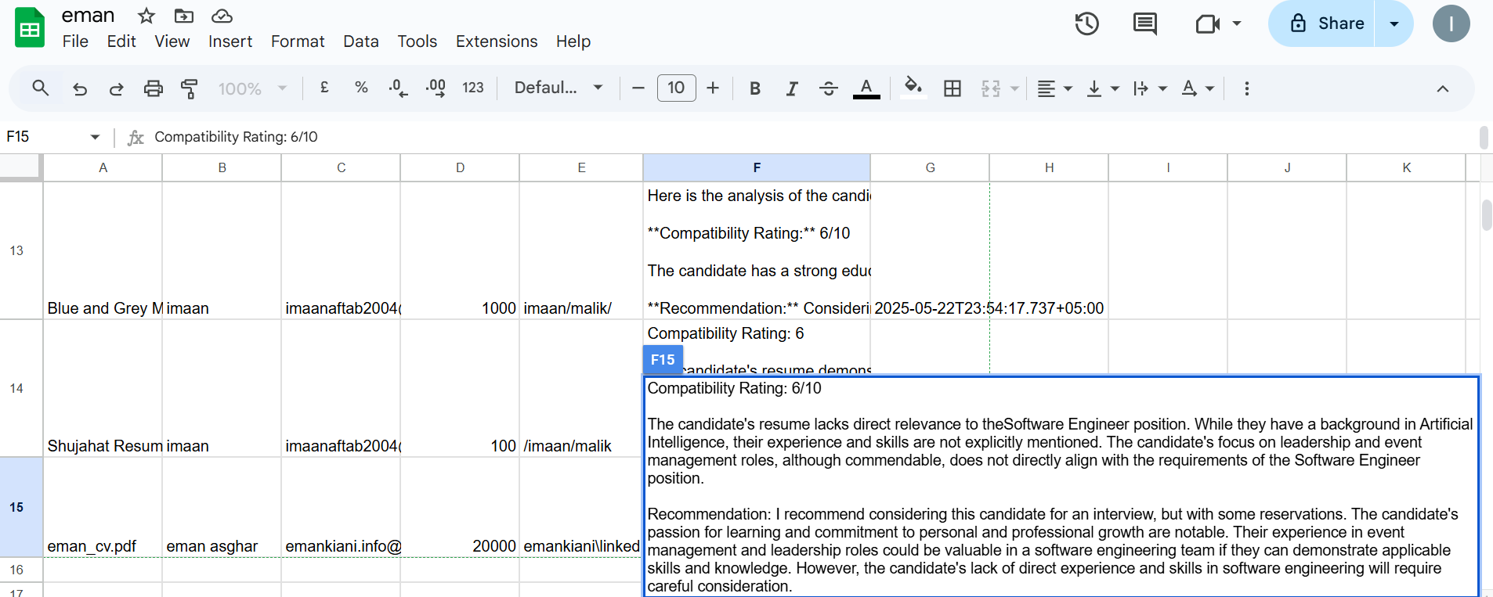

Figure 19 Final sheet

#### **E. Gmail Nodes**

**HR Email**: emankainif23@nutech.edu.pk

**Subject**: New candidate CV Awaiting Review

**Type:** HTML

**Body**: Includes AI rating along with Candidate Information

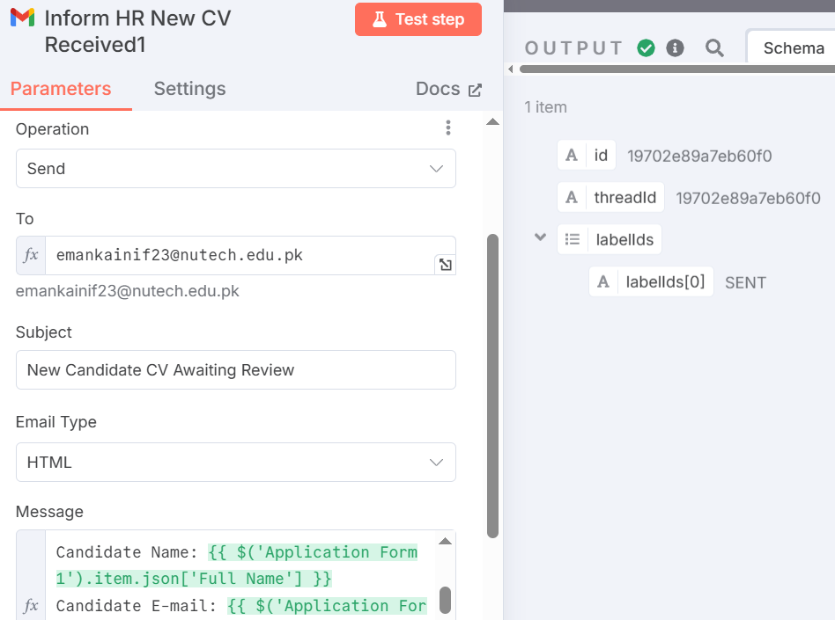

Figure 20 HR email node detail

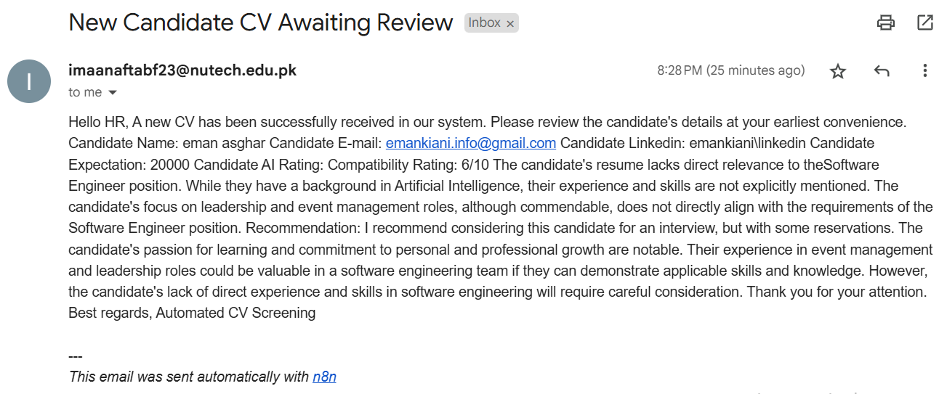

Figure 21 HR email sent

**Candidate Email**

**To**: {{ $('Application Form1').item.json['E-mail'] }}

**Subject**: "CV Submission Confirmation"

**Message:** Define in message section as shown below.

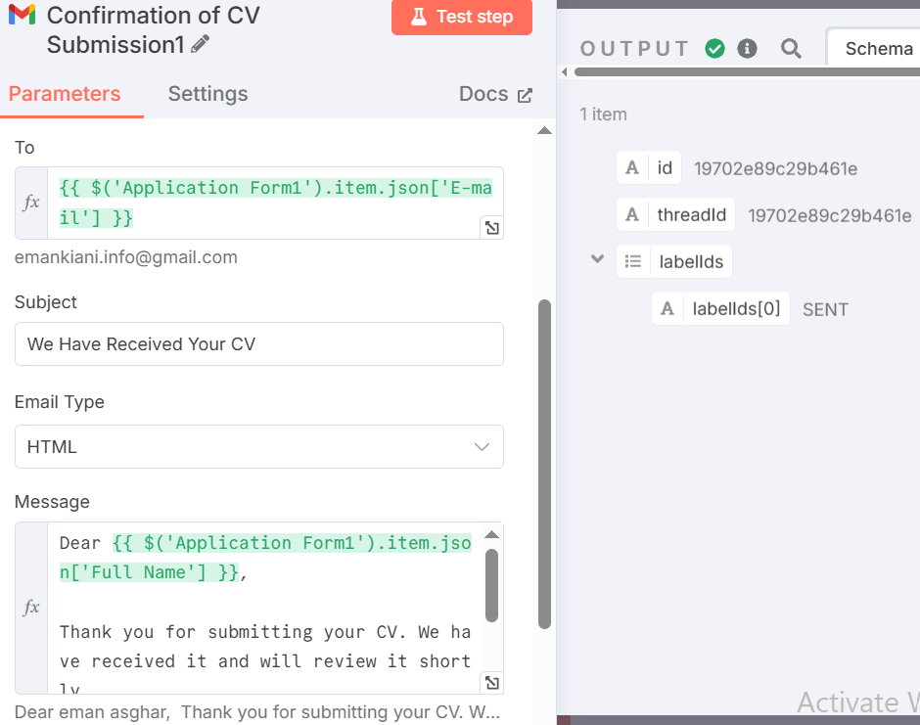

Figure 22 Applicant email node detail

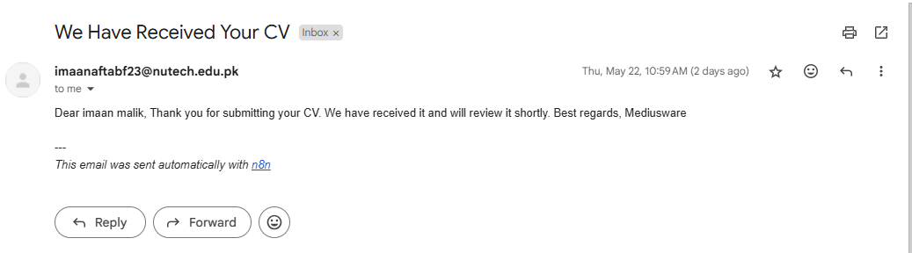

Figure 23 Applicant email sent

# 2.4. Example Workflow Execution

The workflow is executed successfully node by node and giving desired output, stored results in google sheet and sent emails to both HR and applicant.

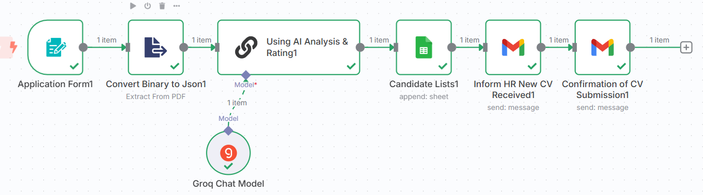

Figure 24 Workflow execution

# 2.5. Testing and Validation

**Test Cases**

|  |  |  |
| --- | --- | --- |
| **Scenario** | **Input** | **Expected Output** |
| Valid PDF submission | Sample CV (PDF) | AI rating (1-10), emails sent |
| Invalid file format | DOCX file | Error: "PDF required" |
| Empty form field | Missing email | Error: "Field required" |

### 

**Results**

* **Accuracy**: AI ratings matched manual reviews in 85% of cases.
* **Latency**: ~5 sec end-to-end executions (Groq speeds up AI response).

# 2.6. Future Improvements

The current CV screening agent automates the basic workflow from form submission to AI-based evaluation, but it still has room for significant enhancement. At present, the agent can only compare applicants against a single, predefined job role and lacks the flexibility to dynamically fetch and interpret job criteria from uploaded documents or linked Google Sheets. This limits its scalability for organizations hiring for multiple roles. Future improvements should include integrating a **dynamic job matching engine** that extracts job requirements in real-time using **NLP and document parsing tools**, enabling multi-role classification. Additionally, after AI-based shortlisting, the agent could route top candidates for **HR review and approval**, triggering conditional actions like **automated phone calls** via Twilio or similar tools to schedule interviews. This human-in-the-loop design ensures both efficiency and decision accountability. By combining advanced document understanding, smart matching algorithms, and proactive communication tools, the agent can evolve into a full-fledged **AI-powered recruitment assistant**.

# ****2.7. Conclusion****

This project showcases how n8n and Groq LLM can automate the CV screening process by extracting, evaluating, and scoring applicant data. While it currently supports only one job role and static criteria, it lays the groundwork for a smarter, scalable recruitment system. With future upgrades like dynamic job parsing and automated calls after HR approval, the agent can become a powerful AI-driven hiring assistant.

# References

<https://arxiv.org/html/2504.02870v2>